Name______________________________________________________________________________Period____

Transcription: Do I Know The Answers?

- Which of the following is NOT a difference between DNA and RNA
  - DNA is Double stranded, RNA is single sided
  - DNA uses deoxyribose; RNA uses Ribose
  - DNA is used in all living organisms; RNA is only used by some organisms
  - DNA uses the bases A,T,C,G while RNA uses the bases A,U,G,C

- Proteins are made of:

- When DNA is “copied” to make proteins, a strand of ______________________ (type of RNA) is formed

- When messenger RNA is translated, what new product forms?

- The mRNA leaves the nucleus and goes to a ____________________ (organelle) where it is used to build a protein.

- mRNA is made up of a bunch of three letter sequences called _______________.

- During Translation, which type of RNA is used to bring the amino acids to the forming protein?

Use the following chart to answer the next two questions:

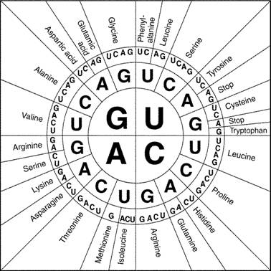

- Transcribe and translate following: TACCGGACC
- What amino acid is coded by the mRNA codon CGA?

Use this picture to answer the next question:
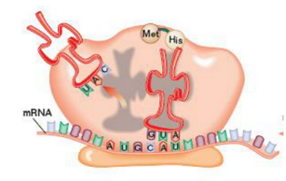

10. Why is the t-RNA above matching up with the Codon CAU?

11. A codon is how many bases long?

12. What makes one protein different from another?

13. What is the job of the tRNA?

14. Where is the information that directs protein synthesis found in DNA?

15. Give two examples of negative effects caused by a mutation?

16. Name something that is NOT considered a physical or chemical mutagen?

17. What was Chargaff’s main contribution to genetics?

18. The type of mutation in which part of a chromosome is lost is a:

19. When one base is changed to a different base, this is considered a:

20. Restriction enzymes are used in what genetic technology?

21. Color blindness is sex-linked and recessive. Patrick has normal vision. Patti is normal, but she has the color blind allele (she is a carrier). What is Patrick’s genotype?

22. What is Patti’s genotype?

23. What percentage of their BOYS will be colorblind?

24. How many chromosomes do humans have?

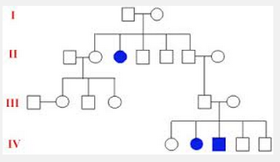

25. What type of inheritance shown in the pedigree above is most likely?

The following pedigree shows the passage of color-blindness in a family. Color-blindness is sex-linked and recessive. In this pedigree, carriers are NOT half-shaded in, so you’ll have to do some detective work to find them.
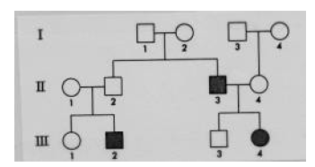
26. What is the genotype of individual #1 of the SECOND generation (second row)?

27. A nucleotide consists of what three things?

28. The twisted ladder shape of DNA is called a:

29. Give the complimentary strand of DNA to the following DNA strand: ATGCCGATGCTAATCA.
30. What bonds hold the two strands of DNA together?

31. The diagram shows the three parts of DNA. What is number 2?

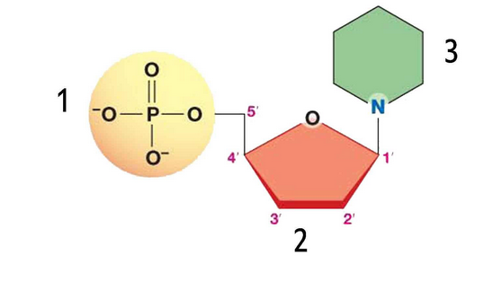

Answer #32-35 with the following answer choices:
A. No amino acid will be different
B. One amino acid will be different
C. Many amino acids will be different
D. The protein will be shortened by an early STOP codon
32. CCAUCACUGUGUGA
Changes To
CCAUCACUCUGUGA

33. CCAUCACUGUGUGA
Changes To
CCAUCAAUGUGUGA

34. CCAUCACUGUGUGA
Changes To
CCAUCCUGUGUGA

35. CCAUCACUGUGUGA
Changes To
CCAUCAACUGUGUGA
36. Which of the above questions (32 to 35) are frameshift mutations?

37. Write the correct mRNA sequence that would result from the following DNA sequence: CCCAAGTCT

38. If a female who is colorblind marries a male who is normal, what are the possible phenotypes of their children?

