**Macromolecule Practice Test**

**1.** What are 6 major elements in living things?

A. hydrogen, helium, carbon, nitrogen, oxygen, chlorine

B. oxygen, hydrogen, nitrogen, carbon, helium, lithium

C. hydrogen, nitrogen, oxygen, carbon, phosphorus, fluorine

D. carbon, hydrogen, oxygen, nitrogen, fluorine, chlorine

E. carbon, oxygen, hydrogen, phosphorus, sulfur, nitrogen,

**2.** Identify the 4 major macromolecules cells are made of?

A. lipids, carbohydrates, proteins, nucleic acids

B. fats, meats, phospholipids, sugars

C. polysaccharides, steroid, proteins, enzymes

D. carbohydrates, enzymes, sugars, proteins

E. lipids, hormones, fatty acids, steroids

**3.** In cells what are carbohydrates used for?

A. transport oxygen to the cells

B. build structures and speed up chemical reactions in the cell

C. store and genetic information and instructions for cell processes

D. store energy and control water movement in the cell

E. used to make cell walls and provide energy for the cell

**4.** Enzymes and meat are examples of what kind of macromolecule?

A. proteins

B. carbohydrates

C. nucleic acids

D. lipids

E. fatty acids

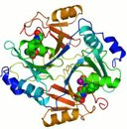**5.** Which type of macromolecule can have a structure like the one shown to the right?

A. carbohydrate

B. a lipid

C. a nucleotide

D. a protein

**6.** DNA and RNA are examples of what kind of macromolecule?

A. nucleic acids

B. fatty acids

C. amino acids

D. lipids

E. carbohydrates

**Answer the following question based on this experiment.**

pH ranges from 1 to 14, 1 is very acidic and 14 is very basic. An experiment is performed to see how plants respond to acid rain. Water plants are placed in water of varying pH measurements. The pH levels are 2.5, 6.0, 7.0, and 11.0. Each day, the health of the plants is measured by counting the leaves and recording the color.

**7.** Which pH is the best control for this experiment?

A. 2.5

B. 6.0

C. 7.0

D. 11.0

**8.** A quantitative observation:  
A. describes something exactly.  
B. is a measurement.  
C. does not depend upon numbers.  
D. is a general description.

**9.** Explain the difference between the cohesion and adhesion of water.

A. cohesion is water sticking to water and adhesion is water sticking to other molecules

B. in adhesion water dyes making it sticky, in cohesion water is sticky even when it is wet

C. cohesion is when water sticks to different molecules call copartners and adhesion water is used to stick different molecules together.

D. adhesion is water sticking to water and cohesion is water sticking to other molecules

E. adhesion water is used to add molecules to other molecules, cohesion is when water is used to split molecules

**Answer questions 10-11 with the picture below.**

[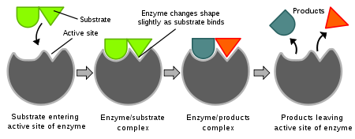](http://en.wikipedia.org/wiki/File:Induced_fit_diagram.svg)

**10. What concept is portrayed in the picture above**

A. Enzyme helping digest a substrate into products

B. Enzyme synthesizing substrates to make one product

C. Enzyme building large molecules for the body

D. Arrows, circles, triangles, lines, and puzzles

**11. Which statement is true concerning the picture**

A. An enzyme active site will change for any type substrate

B. An enzyme active site changes shape after product leaves

C. An enzyme active site is specific to one shape of substrate

D. Any enzyme cannot bind with the substrate above

**This picture shows a beaker that was filled with water. Over time the water obviously moved up into the tube. A – D shows the tube at different time intervals.**

**12.** Which property of water allows it to move up the tubes shown?

A. Adhesion and Cohesion

B. High Specific Heat

C. pH

D. Forms solutions

**13-16** Match the Function with the Macromolecule

**13.** Carbohydrate A. Carries the genetic code

**14.** Lipid B. Energy storage inside of plants

**15.** Protein C. Insulation in seals

**16.** Nucleic Acid D. Enzymes

**Match the monomer below with the appropriate macro-molecule in the questions below**

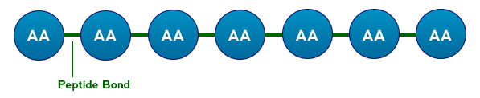

A.

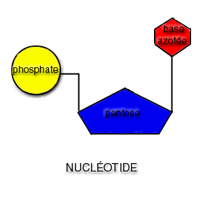

C.

B.

D.

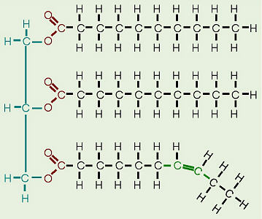

**17.** Fatty Acid

**18.** Protein

**19.** Nucleic Acid

**20.** Carbohydrate

**This graph shows the reaction rate of an enzyme**

**Use the graph to answer the questions 21-22**

 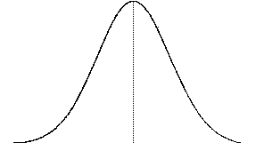

**21. What statement below is false about this picture**

A. As the pH moves up from optimal the enzyme activity goes down

B. As the pH moves down from optimal the enzyme activity goes down

C. As you approach the optimal pH, the enzyme activity stops

D. As optimal pH is reached the activity is the highest

**22. What is the optimal pH of the enzyme above**

A. Between 3 – 4 B. Between 10-11

C. Either 2 or 13 D. Between 7-8

**23. What is the overall function of enzymes?**

A. They act as catalysts that speed up reactions.

B. They are carbohydrates that used for energy

C. They are lipids that help insulate animals

D. It is a code that can be unlocked with a password.

**Use the bar graph below to answer question 24**.

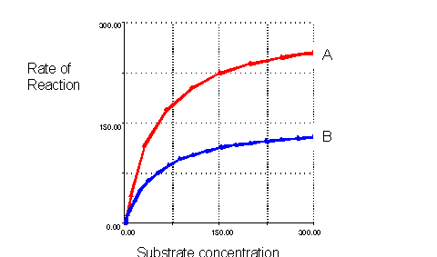

X

**24. This graph shows rates of the same enzyme, what could cause the difference in the two lines above?**

A. Same Temperature

B. Different temperature

C. Similar acidity

D. Different people

**25. Water is polar in nature. To be polar means to:**

A. be very cold and difficult to warm up.

B. freeze easily and boil rapidly

C. have positive and negative charged ends

D. have a low heat capacity

**26. Why is water considered the universal solvent?**

A. It is cohesive and will travel to the top of a tree.

B. It dissolves substances better than most things.

C. It acts like a great buffer.

D. It makes things stick to other things

27. What allows a water bug to remain on the top of the water?

A. capillary action in the bug’s legs

B. surface tension of the water molecules

C. The fact that water is the universal solvent

D. water is denser as a liquid

28. What property of water allows it to attach to other surfaces?

A. hydrogen bonding

B. solvent

C. adhesion

D. cohesion

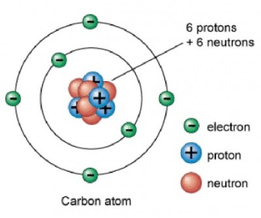29. Carbon has 4 valence electrons in its outer shell, how many bonds can carbon form with other elements?

1. 2
2. 3
3. 1
4. 4

30. How do electrons in an **ionic** bond behave?

A. electrons flow freely between atoms

B. electron number is reduced

C. atoms gain or lose electrons

D. atoms share pairs of electrons

31. Where would you expect to find protons?

A. in the outer shells

B. outside the nucleus

C. in the nucleus

D. attached to the electrons

32. What does the atomic number indicate about the atom?

A. the mass of the atom

B. the number of protons in the atom

C. the number of neutrons in the atom

D. the number of electron shells

33. The diagram below shows a chemical reaction involving an enzyme. The box-like structure is most likely

A. a molecule of oxygen

B. the enzyme

C. The end product

D. The substrate