Name: ______________________________________________________________________________________________ Period:__________
Find My Family!

There has been a local emergency at the hospital! All of the newborn babies were evacuated without any of their paperwork or records. We need you and your expert knowledge to help us match the babies to their parents! Use the following traits and their dominant and recessive genes:
Trait | Dominant Phenotype | Recessive Phenotype
Eye Color (E) | Brown | Blue
Hair Color (C) | Dark | Light
Freckles (F) | None | Freckles
Skin (S) | Dark | Light
Hair Texture (T) | Curly | Straight
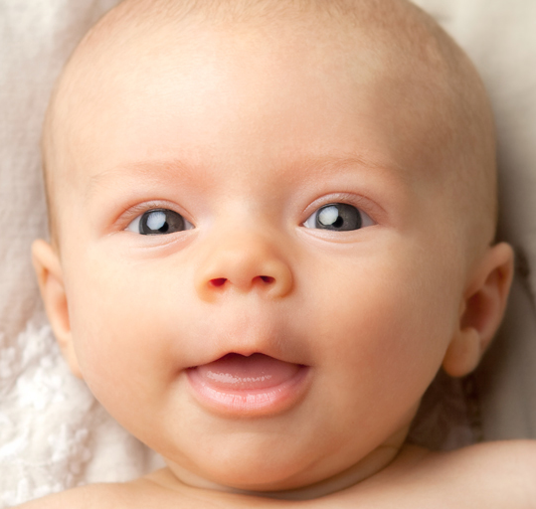
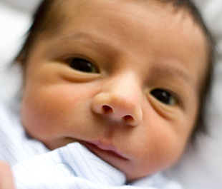
Baby #1 Baby #2

Eyes: Brown Eyes: Brown
Hair: Light Hair: Dark
Freckles: None Freckles: Yes
Skin: Light Skin: Light
Hair Texture: Straight Hair Texture: Straight

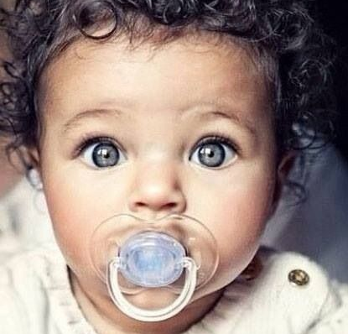
Baby #3 Baby #4

Eyes: Brown Eyes: Blue
Hair: Dark Hair: Dark
Freckles: None Freckles: None
Skin: Dark Skin: Dark
Hair Texture: Curly Hair Texture: Curly

Luckily, all of the potential parents know their genotypes. Use the parents’ genotypes to make punnett squares and match these adorable babies to their rightful parents!

Parents #1: Harold and Amy

Harold:

Eyes: Brown (EE)
Hair: Dark (Hh)
Freckles: None (Ff)
Skin: Dark (SS)
Hair Texture: Curly (TT)

Amy:

Eyes: Blue (ee)
Hair: Dark (HH)
Freckles: None (Ff)
Skin: Dark (Ss)
Hair Texture: Straight (tt)

Who’s our baby? _______________________________________________
Parents #2: Tim and Becky

Tim:

Eyes: Brown (BB)
Hair: Light (hh)
Freckles: Yes (ff)
Skin: Light (ss)
Hair Texture: Straight (tt)

Becky:

Eyes: Blue (bb)
Hair: Dark (HH)
Freckles: Yes (ff)
Skin: Dark (Ss)
Hair Texture: Straight (tt)

Who’s our baby? _______________________________________________

Parents #3: Henry and Michelle

Henry:

Eyes: Brown (Ee)
Hair: Light (hh)
Freckles: None (FF)
Skin: Dark (SS)
Hair Texture: Curly (TT)

Michelle:

Eyes: Blue (ee)
Hair: Dark (HH)
Freckles: None (Ff)
Skin: Dark (Ss)
Hair Texture: Straight (tt)

Who’s our baby? _______________________________________________

Parents #4: David and Leslie

David:

Eyes: Brown (EE)
Hair: Dark (Hh)
Freckles: Yes (ff)
Skin: Light (ss)
Hair Texture: Curly (Tt)

Leslie:

Eyes: Blue (ee)
Hair: Dark (Hh)
Freckles: None (Ff)
Skin: Light (ss)
Hair Texture: Straight (tt)

Who’s our baby? _______________________________________________

