Name___________________________________________________________________________________________ Period: _______________________
Enzyme Lab
Questions:
- What happens to the flavor of a Saltine cracker when it is not chewed?
- What happens to the texture of a Saltine cracker when it is not chewed?
Independent Variable (what I’m changing):__________________________________________________________________
Dependent Variables: (what I’m measuring):_________________________________________________________________
Hypothesis #1: If the cracker is not chewed then the flavor will ___________________________________________ ______________________________________________________________________________________________________________________
Hypothesis #2: If _______________________________________________________________ then the texture will ________ ______________________________________________________________________________________________________________________
Materials:
One saltine cracker
1 Stopwatch
Procedure:
- Break the saltine cracker in half--- DO NOT EAT THE ENTIRE CRACKER AT ONCE
- Chew and swallow half of the saltine cracker and record observations on the texture and flavor of the cracker
- Wait 3 minutes
- Place the other half of the saltine cracker in the mouth and hold for 3 minutes without chewing or swallowing and record observations
Data:

Chewed
Texture | Flavor

Not Chewed
Texture | Flavor

Analysis Questions:
1. How was the cracker able to breakdown in your mouth without you chewing it?

2. Why did the taste change from salty (when you chewed it) to sweet (when you did not chew it)?--- If this didn’t happen for you still explain why this SHOULD have happened.
3. The two graphs below show the results of an experiment where a saltine cracker was placed in a test tube with saliva. Graph A shows the change in starch over time. Graph B shows the change in glucose over time. Using the graphs answer questions 3A & 3B. 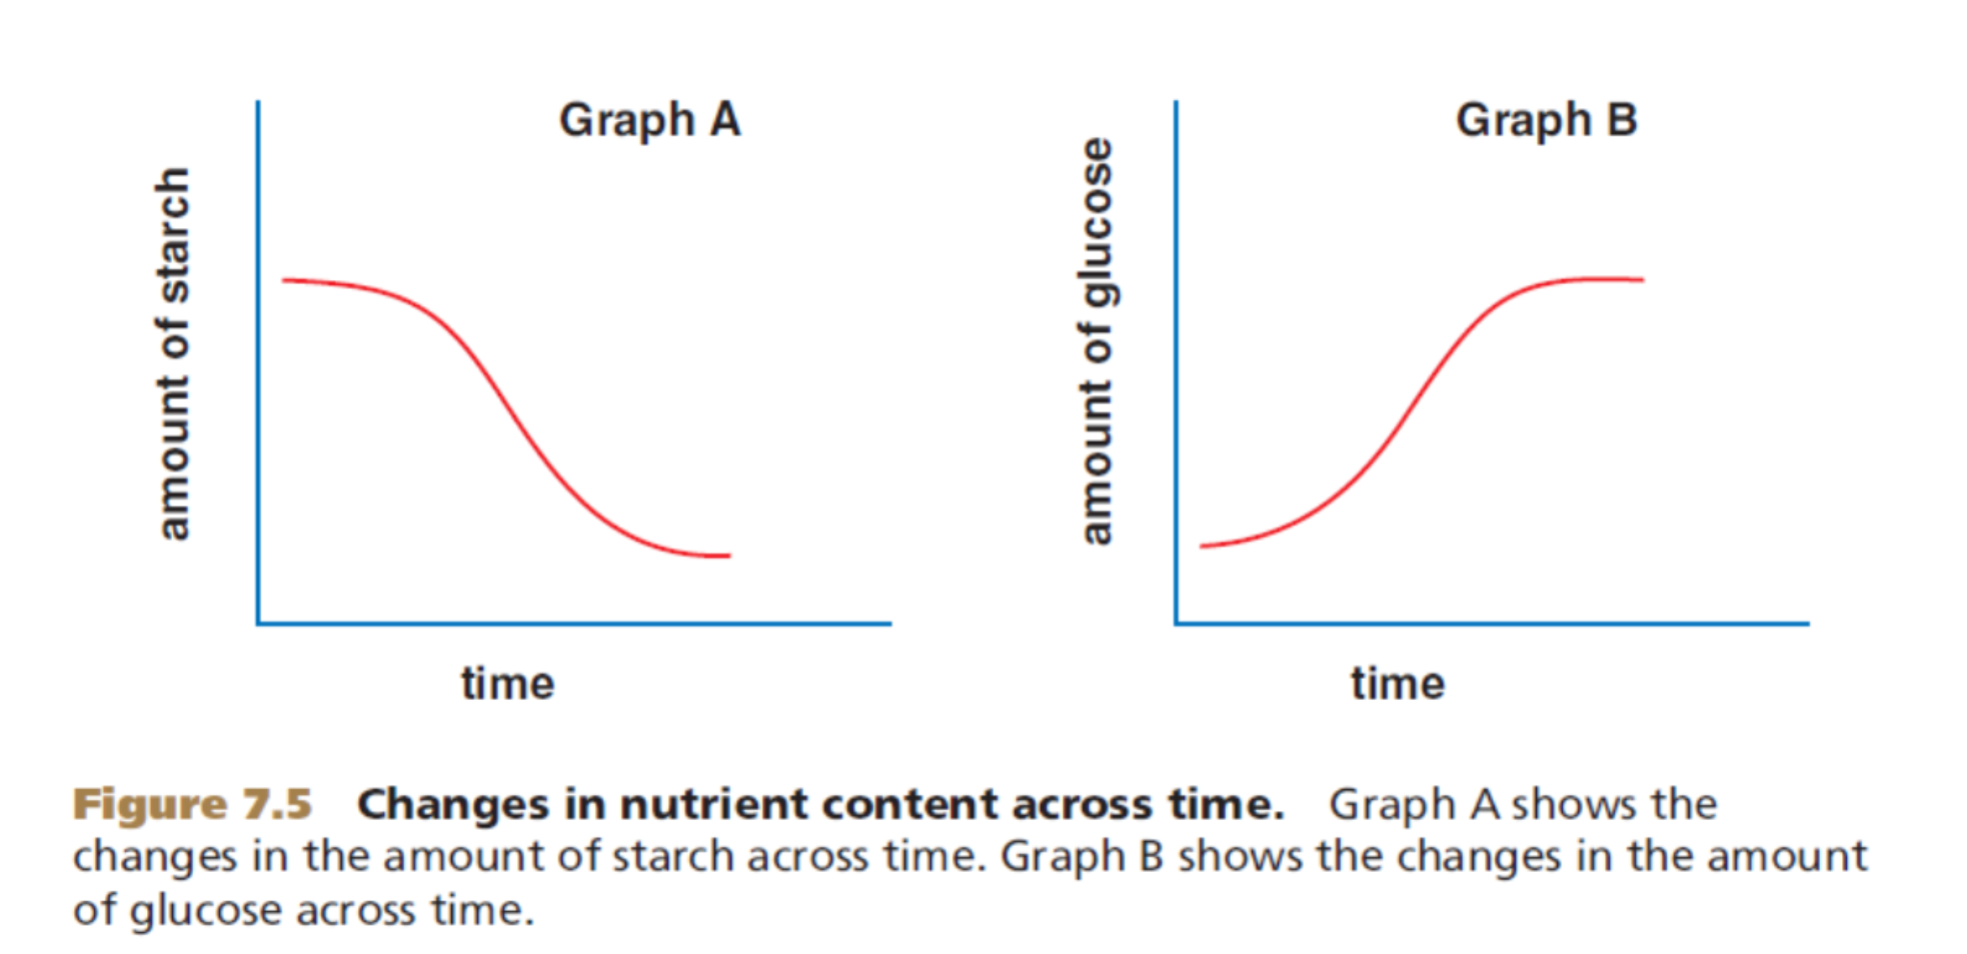
3A: Explain what is happening to the amount of starch OVER TIME and why that is happening.

3B: Explain what is happening to the amount of glucose OVER TIME and why that is happening.

4. What are two reasons why you chew food?

5. What is the function of an enzyme?

6. The function of the small intestine is to finish breaking down nutrients and absorbing them into the bloodstream. How does this apply to macromolecules?

7. A way to affect enzymes is to change the pH. If we lowered the pH to 3, what do you think would have happened to test tube B?

Experiment 2:

- Take a small piece of the smashed up crackers at the front and put in test tube “A”
- Take another small piece of smashed up crackers and put it in test tube “B”
- To test tube A, add 5mL of water.
- To test tube B, add 5mL of saliva (from your mouth)
- Swish and mix each test tube and allow to sit at room temperature for 5 minutes.
- After 5 minutes, add one drop of Iodine to each test tube and observe what happens.

