Name_______________________________________________________________________Period___________

Ecology: Do I Know the Answers?

- Using the following organisms, arrange them in the correct order of energy flow.

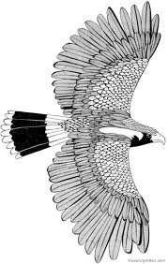
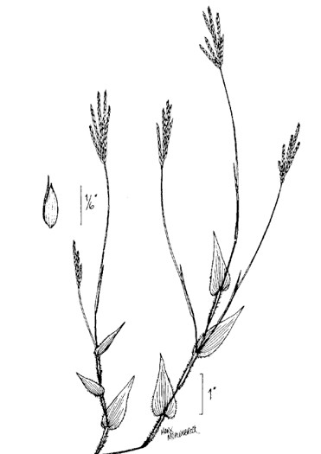
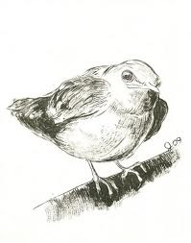
2
4
3
1
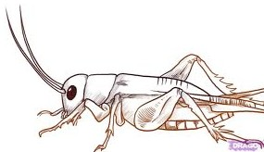

- Using the pictures above, identify the producer.

- Using the pictures above, identify the tertiary consumer.

- Using the pictures above, identify the secondary consumer.

- Using the pictures above, identify the primary consumer.

- If producers in an energy pyramid have 10,000 kcal (kilocalories) available to them, how much energy would be available for a secondary consumer?

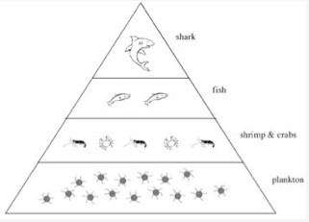
Suppose 12,970 kcal of energy were available to the organisms at the bottom level of the diagram.

- How many kilocalories of energy would be available to the organisms at the fish level?

- As you move from one level to the next, only ______________% of the energy is converted or given to the next organism. _____________% is lost as heat, growth or reproduction.

- What strategy would a bear would use to balance out the energy requirements during times when food is unavailable?

- What is a strategy a bird would use to balance out the energy requirements during times when food is unavailable?

- Would a starving coyote expend his energy to chase after a mouse?

- Is the energy gained from the nectar of a flower worth the effort a hummingbird spends acquiring it?
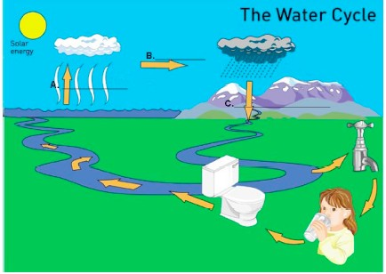

- In the diagram, A represents:

- In the diagram, B represents:

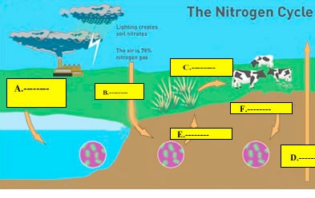
- In this diagram, what letter represents dentrification?

- In the diagram above of the Nitrogen Cycle, what letter represents the process by which bacteria in the soil converts ammonia to nitrites for plants?

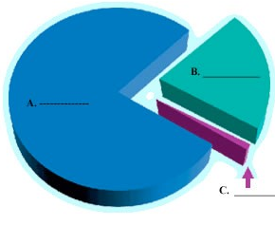
- Provided is a pie chart indicating the available gases in the atmosphere. Indicate what letters A, B and C represent (in that order).

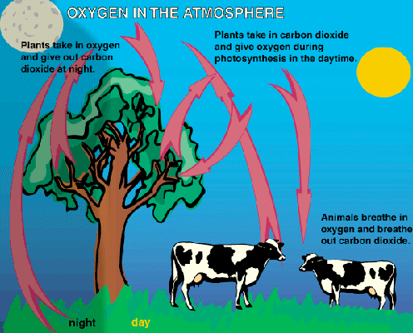
- In this diagram, why are these arrows going to and from plants to carbon dioxide?

The diagram below shows a part of the Carbon Cycle.
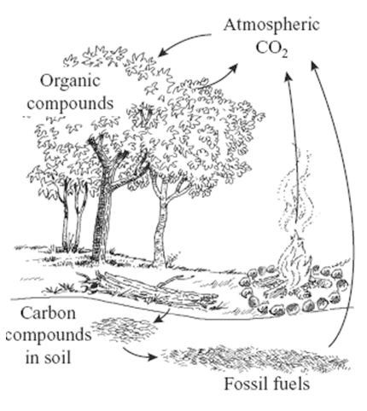
- If many trees are removed from a forest by logging, what is the most immediate effect on the carbon cycle in that forest?
- What human activity has added the most carbon to the atmosphere?

- How do humans have the greatest impact on the water cycle?

In attacks on sheep and goats, coyotes typically bite the throat just behind the jaw and below the ear. Death commonly results from suffocation and shock; blood loss is usually a secondary cause of death. On small pretty, such as young lambs and kids (baby goats), coyotes may kill by biting the head, neck or back, causing massive tissue and bone damage.

- Identify what type of species relationship is demonstrated between the coyote and the sheep and goats.

- Using the story above, explain what is going on in this relationship.

Elk are predominantly grazers (eating grasses and flowering plants) and mule deer are predominantly browsers (eating shrub leaves, stems and buds). Diets of the two species change seasonally and at times, they may struggle directly for the same food. For example, newly growing flowering plants and grasses are important to both elk and mule deer in the spring, and elk with consume a variety of shrubs and willows also eaten by mule deer in the winter.

- Identify what type of species relationship is demonstrated between the elk and the deer?

- Using the story above, explain what is going on in this relationship.

A catfish producer in Mississippi has noticed that 50% of the fish on one of his five ponds are dying. When the fish from that pond are cut up and packaged, he notices that the meat is discolored and has an “off” odor. There seems to be a lot of “green stuff” floating on the surface of his pond and he wonders if the presence of the green stuff could be related to the death of his fish.

- Give a quantitative observation from the above story.

- What would be a good hypothesis for the catfish producer to test?

- Give a qualitative observation from the above story.

- The following graph shows the relationship of plant growth to temperature. State therelationship between temperature and plant growth:
Temperature
Rate of Photosynthesis

Use this graph to answer the following question.
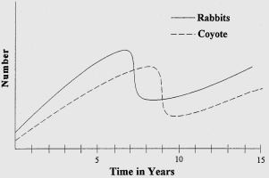
- What influences the population of the coyotes?

- Ecologists discovered that trout were dying in a stream that ran through some farmland where nitrogen fertilizer was used on the crops. Create a hypothesis that explains what could be happening.

- Due to the climate in which we live, name two factors that could limit the food sources of wildlife?
- What happens to the number of organisms as you move up a food pyramid?
- What must balance the energy needed by a predator as it chases prey?

- Sally’s dog has become obese. How would a biologist describe the cause?

- A monkey drops food from the treetops. Deer eat this food. The deer sound a warning stomp when predators are in the area. This interaction occurs from generation to generation. What is happening here?

- The deer in the above example begin to rapidly decline in population. What could be a possible biotic limiting factor?

- Name three abiotic factors in an ecosystem.

- A cow eats grass, and converts the grass into chemical energy. Name a type of energy that the cow’s chemical energy could NOT be transformed into.

