Name: _____________________________________________________________________________________________________________ Period: _________________

Cells Test Study Guide

Organelles
Label the organelles and their function. Which letter represents them in the diagram?

1.
2.
3.
4.
5.
6.
7.
8.
9.
10.
11.
12.

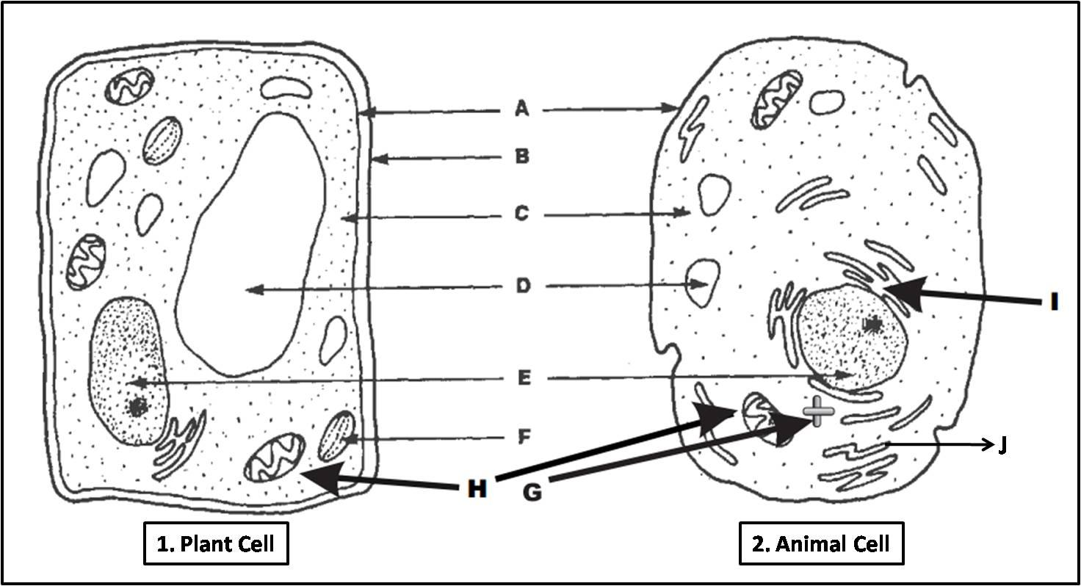
Cell Theory
What are the 3 parts to the Cell Theory?

Who helped create the Cell Theory?

Who named the cell and wrote a book called Micrographia?

Who made a better microscope?

Mitochondria
Explain the steps of Cellular Respiration.

What is the equation? Which are the reactants and which are the products?

What is fermentation?

What is the product for plants and what is the product for animals?

What is anaerobic activity?

How does mitochondria rely on the cell membrane?

What 3 things does it need?

Chloroplast
What are the steps to photosynthesis?

What is the equation? Which are the reactants and which are the products?

What is chlorophyll?

What color does it reflect?

Diffusion
What are the 3 different kinds of diffusion?
1.
2.
3.

Which one only moved water?

Which one requires energy?

Which ones go from a high to low concentration?

Which one can go from a low to a high concentration?

What does semi-permeable or selectively permeable mean?

Define Osmosis

What are the three different types of solutions? What do they mean?
1.
2.
3.

What do you think the cell will try to do if placed in a different type of solution than it came from?

1. In osmosis, water always moves toward the ____ solution: that is, toward the solution with the ____ solute concentration.
- isotonic…greater
- hypertonic…greater
- hypertonic…lesser
- hypotonic…greater
- hypotonic…lesser

- Sea water is dangerous to drink because
  - one cup of sea water contains enough sodium to poison you.
  - sea water is hypertonic to your body tissues and drinking it will cause you to lose water.
  - sea water is isotonic to your body fluids and you will absorb too much water.
  - the salt causes hypertension and you will promptly die of a stroke.
  - it contains toxic levels of iodine.

- If the volume of a cell increases when it is placed in a solution, that solution is said to be __________ to the cell.
  - hypertonic
  - subatomic
  - isotonic
  - gin and tonic
  - hypotonic

Prokaryote vs. Eukaryote
What is a Prokaryote?

List examples.

What is a Eukaryote?

List at least 3 examples.

Which organelles would a prokaryote be missing?

What is the Endosymbiosis Theory?

What does this theory have to do with the evolution of life on our planet?

What is an autotroph? List as many examples as you can.

What process do autotrophs perform for food?

What is a heterotroph? List as many examples as you can?

What process do heterotrophs perform for energy?

Osmosis

- Flasks X, Y, and Z contain solutions with different concentrations of the solute NaCl.
  - Flask X has 0.5% NaCl
  - Flask Y has 0.9% NaCl
  - Flask Z has 1.5% NaCl
Red blood cells (0.9% NaCl) will be placed into each flask. Predict what will happen to the blood cells in each of the flasks.
  - Flask X: Contract Flask Y: Unchanged Flask Z: Swell
  - Flask X: Swell Flask Y: Unchanged Flask Z: Contract
  - Flask X: Unchanged Flask Y: Swell Flask Z: Contract
  - Flask X: Unchanged Flask Y: Unchanged Flask Z: Unchanged

2. A red blood cell has a salt concentration of 0.9%. What will happen if it is placed into a 1% salt solution? The red blood cell will
    - shrink if its membrane is permeable to both the salt and the water.
    - shrink if its membrane is impermeable to the salt and permeable to the water.
    - maintain its shape - nothing will happen.
    - swell and probably burst because its membrane is impermeable to salt and permeable to water.
    - swell and probably burst because its membrane is impermeable to water and permeable to salt.

Compare and contrast diffusion, osmosis and active transport.

