Name: _________________________________________________________________________________________ Period: _____________

Atom Notes

Particle | Charge | Mass | Location in Atom
Proton
Neutron
Electron

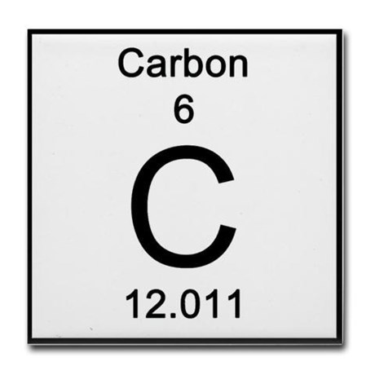

What is an isotope?

How many electrons does an atom need to be stable and not try to bond with any other elements?

How many electrons can fit in the first shell?

How many in the second shell (and every shell after the first…)?

Draw a Carbon atom below. Label each sub-atomic particle.

Type of Bond | Description | Picture/Example | Strength
Ionic

Covalent

Hydrogen

Double

